**IFT 466 Advanced Computer Networks**

**Lab 17  
BGP – Advanced Configuration**

**Objective**Demonstrate how to configure the Border Gateway Protocol (BGP) in a network topology.

1. Setup up the following topology on Packet Tracer

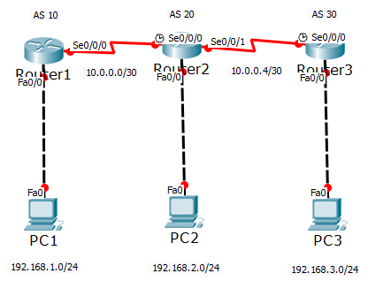



✓

1. Configure the PCs & Routers (both Fast Ethernet and Serial interfaces) with IP addresses.



✓

1. Now we will configure Routers 1 & 2 with BGP

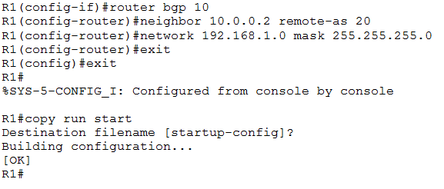

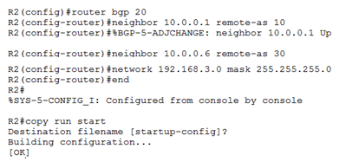

✓

1. Now configure router 3 your self



✓

1. Now let’s check our route tables, like on R2 below

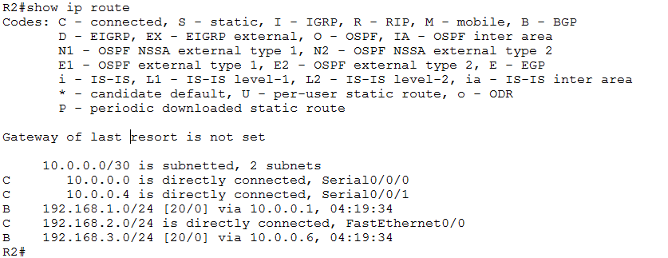

 ✓

1. Did you notice anything wrong with the route tables, perhaps on R1?  
     
   You may have noticed the error already in the configuration of R2 and made the correct change.   
     
   Does R2 advertise the right network?   
     
   You may need to go into R2 and make the change.

✓

1. As well as using the show ip route command to view the route tables, we can also use the show ip bgp summary command to view our neighbor routers.

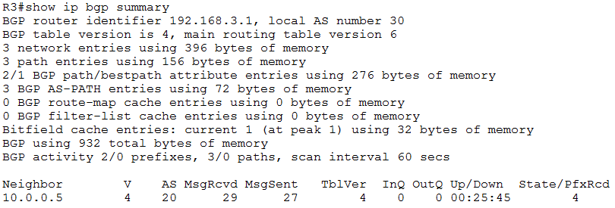

Run the same show command on R2

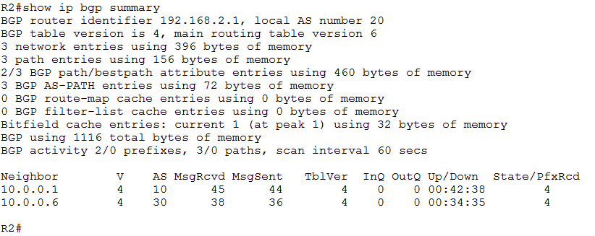



✓

1. Now you should be able to Ping PC2 from PC1

✓

**N.B**. Make sure you save your packet tracer configuration as you will need it for lab 17!